ETL TESTING COURCE

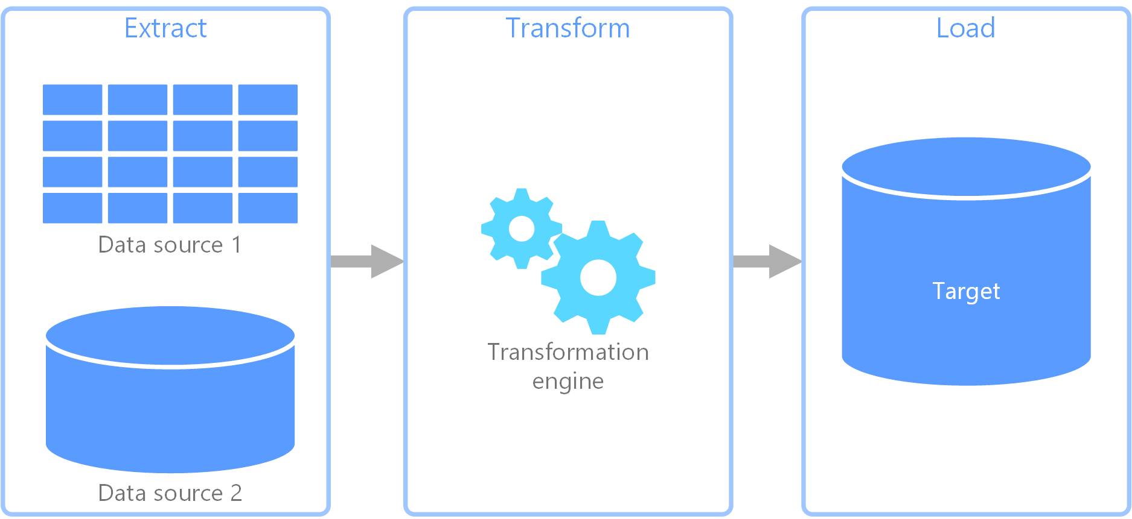

1. Developer also have this same requirement sheet STM SHEET OR MAPPING SHEET

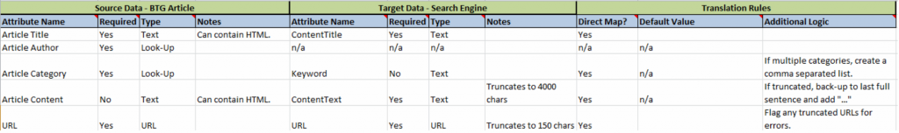

1. Tester First we are getting requirement sheet STM SHEET OR MAPPING SHEET



In that sheet source table and target table with some logic are transformations.

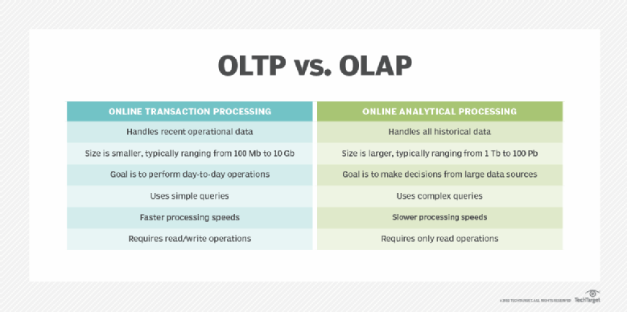

Sources = flat files , excel, csv files, txt files , table(oracle, sql srever),taradata, parquet file

After the tranformations (INFORMATICA , sql servers,data bricks,)

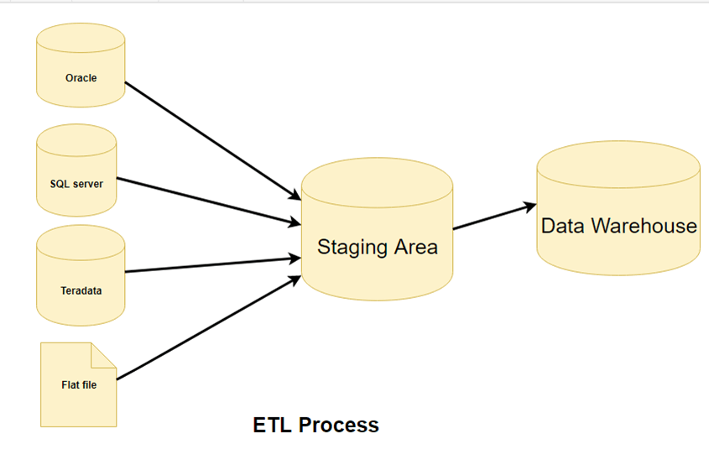Traget=only in table form ( DWH)

Staggng layer

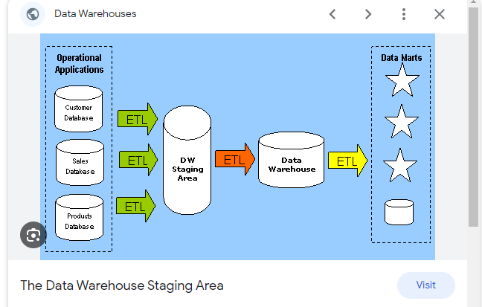

table structure

Columns = fields

Rows= records

|  |  |  |  |  |  |
| --- | --- | --- | --- | --- | --- |
| Columns1 | Columns2 | Columns3 | Columns4 | Columns5 | Columns6 |
| Rows | Salav |  |  |  |  |
| Rows |  |  |  |  |  |
| Rows |  |  |  |  |  |
| Rows |  |  |  |  |  |

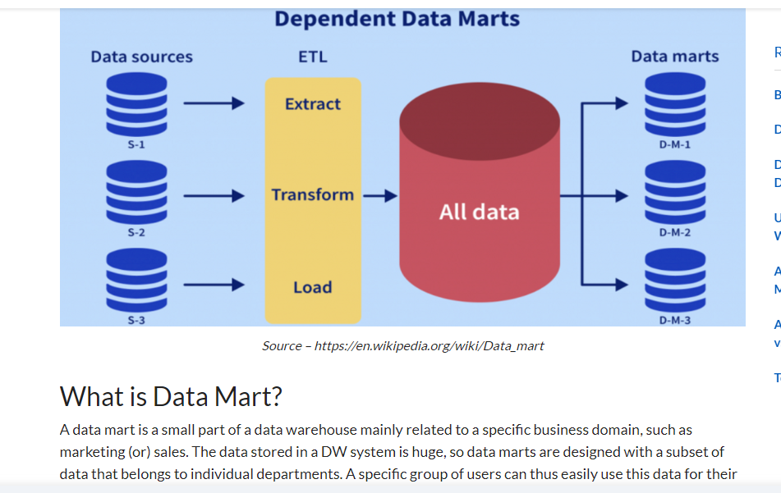

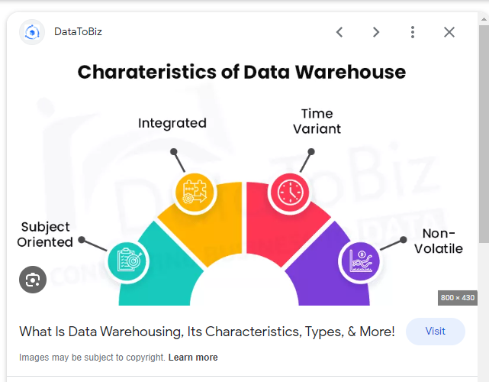

Top down approach

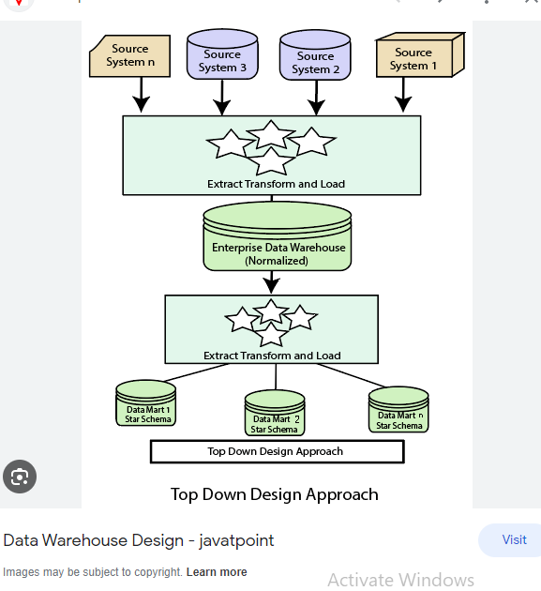

Bottom up approach

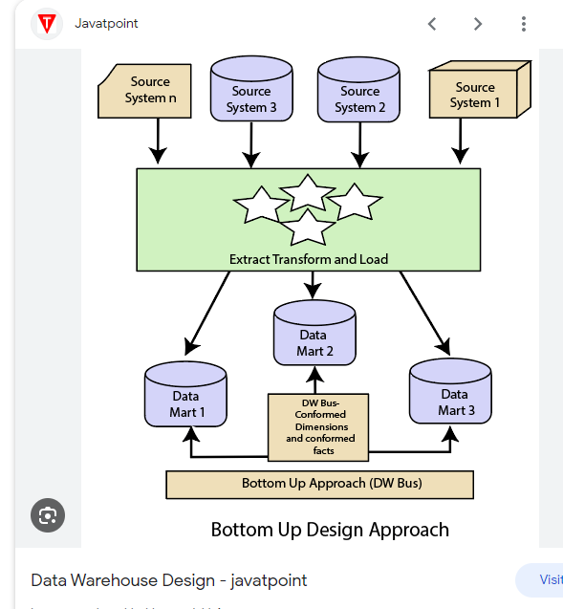

Dimensions

1. conform dymentions
2. Junk dymentions

conform dymentions

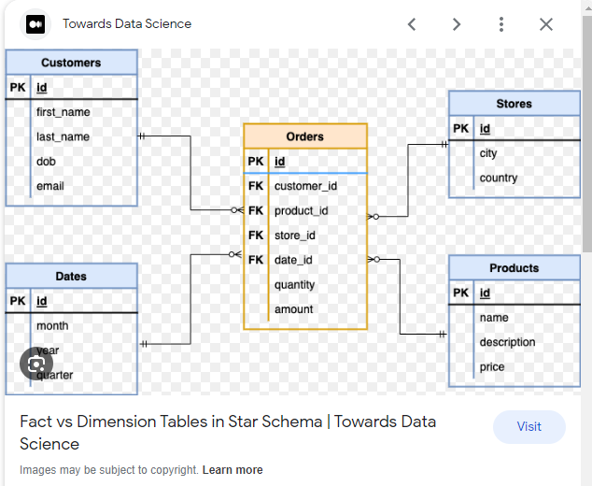

Junk dymentions

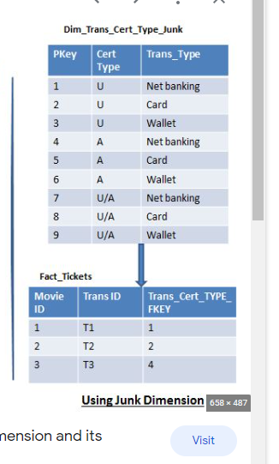

Fact

1.Additive facts = number of dymentions tables connection with one fact table

2.Semi additive some limited dymentions tables connection with one fact table

3.Non additive = there is no connection between dymention and fact table

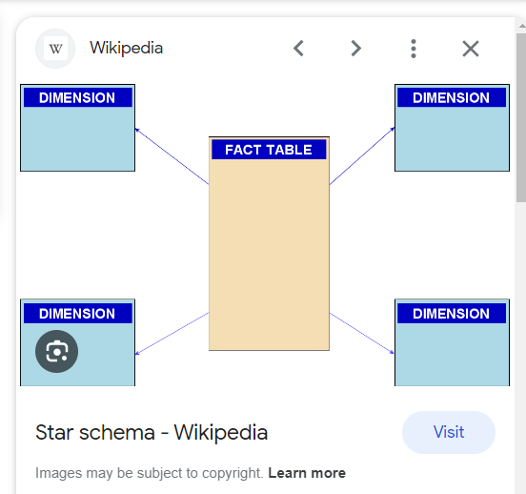

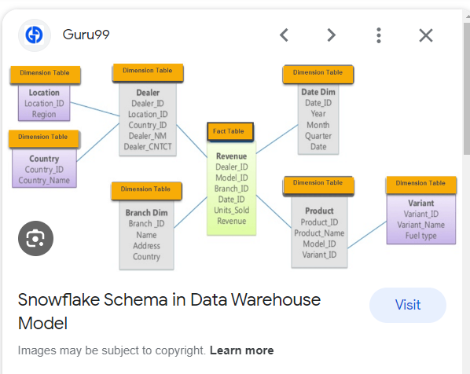

Galaxcy schema

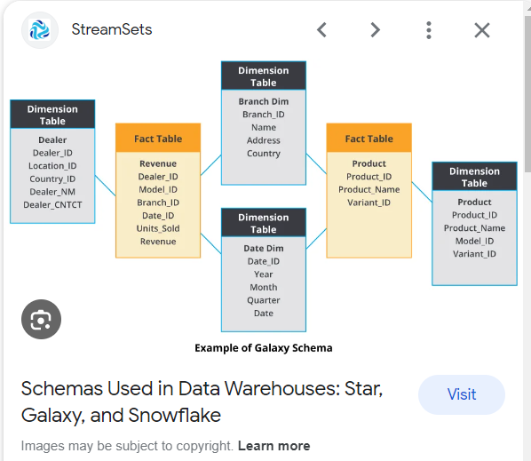

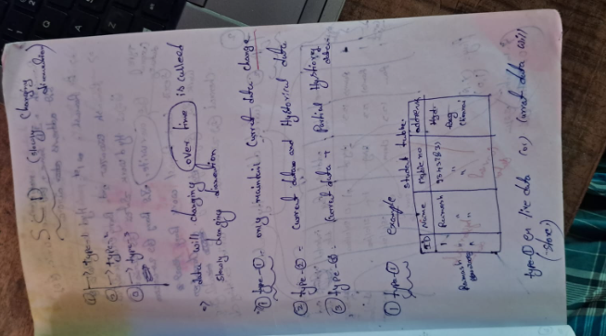

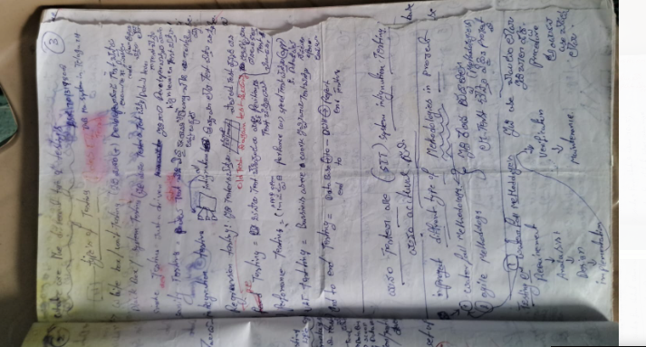

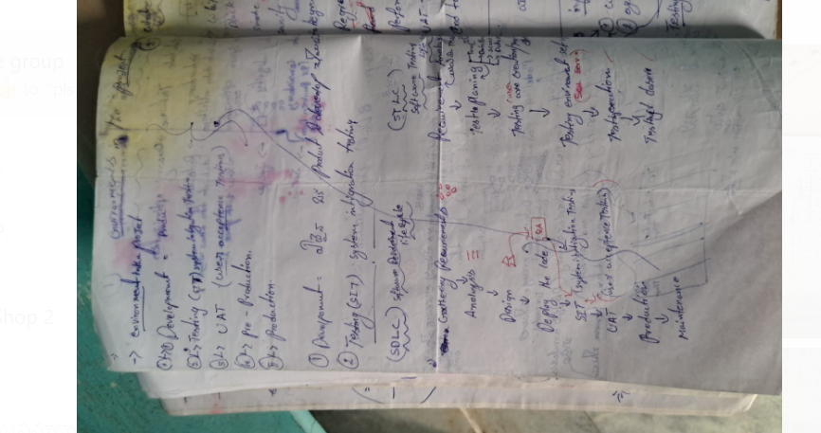

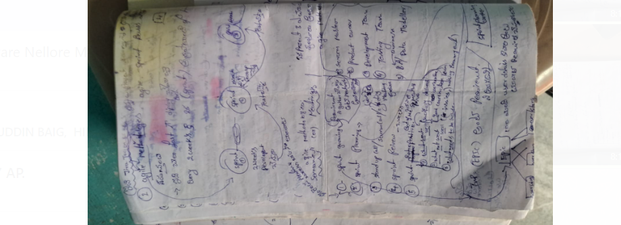

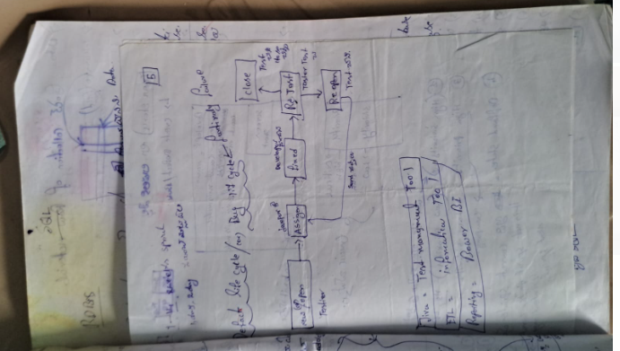

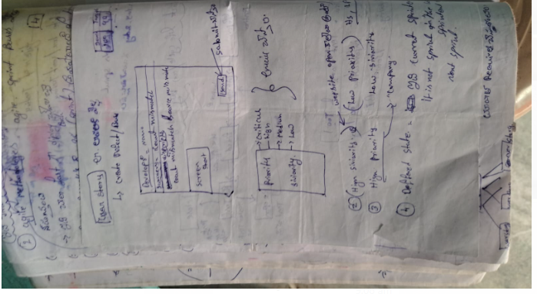

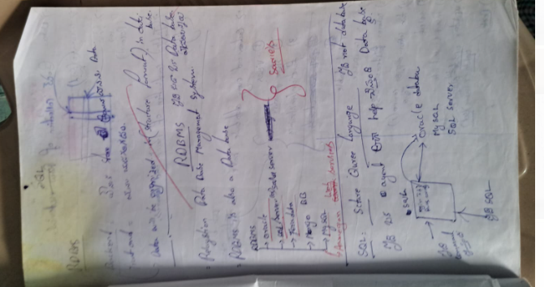

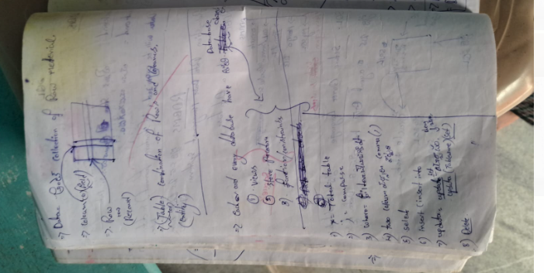

SQL full cource

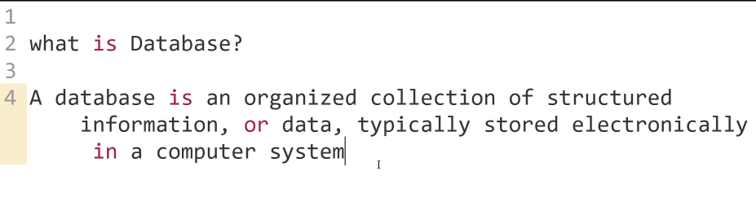

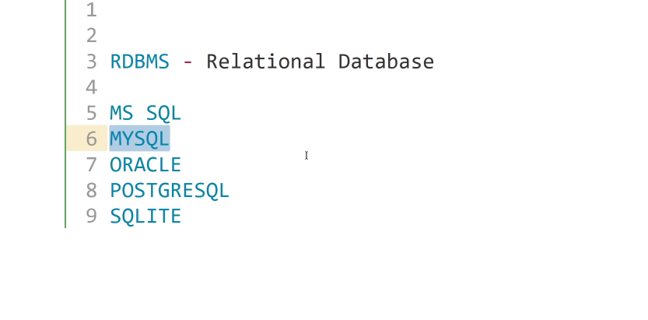

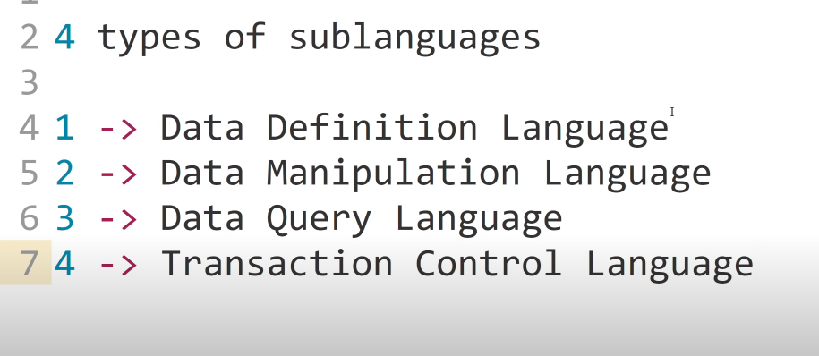

* CREATE DATABASE SQLTAECHING;
* DROP DATABASE SQLTAECHING;
* CREATE DATABASE SQLTAECHING;
* USE SQLTAECHING;

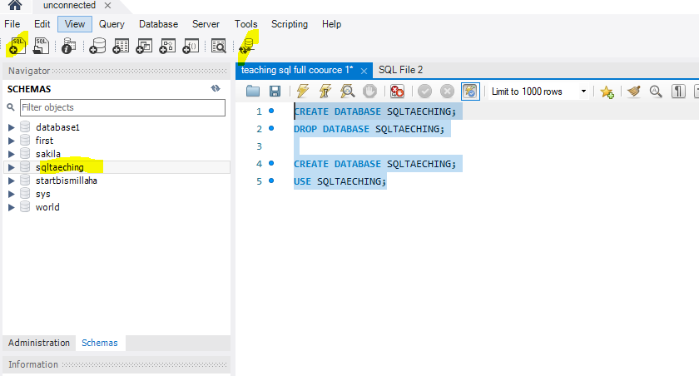­­­­­

Data types

Name column = alfa letters ( char)or(varchar)

Amount(1298.23)= decimal(18,2)

Rollno=(int)

Id(int)=

Address= (varchar or varchar2)

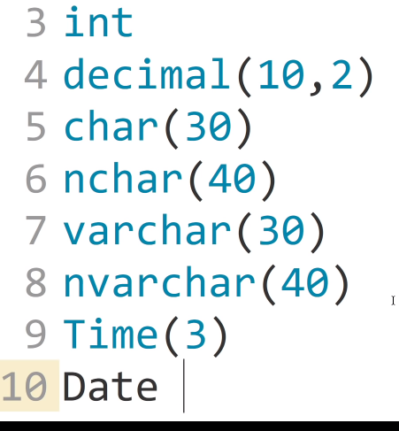

How to create atable in sql

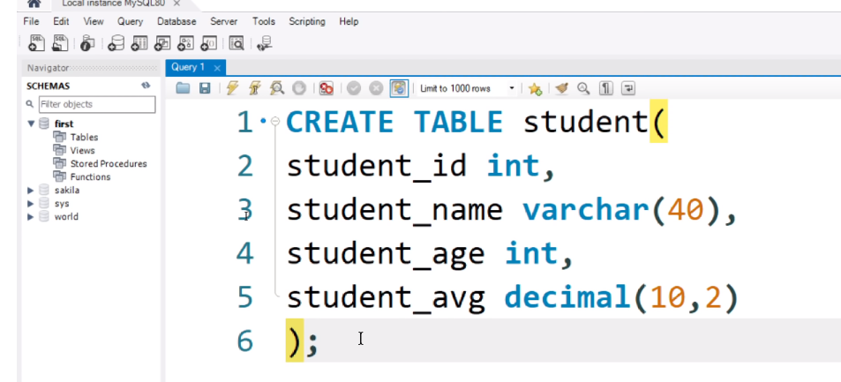

Create table exm table name

(

Colm1 datatype,

Colum2 data type,

Colum3 data type,

Colum etc datatype

);

Varchar(alfa+numbers)

Create table shoppingmall

(

Clothesshop varchar,

hotel varchar,

office_room int,

);

-------------------------

Create table shoppingmall

(

Clothes_shop varchar(20),

hotel varchar(10),

office_room int

);

select* from shoppingmall;

Data Defination language (DDL)

add new column

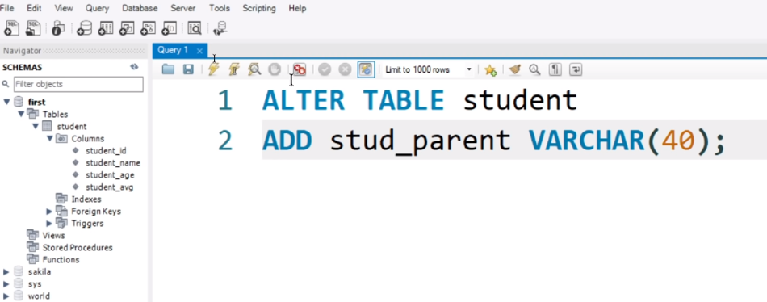

Change column name with data type

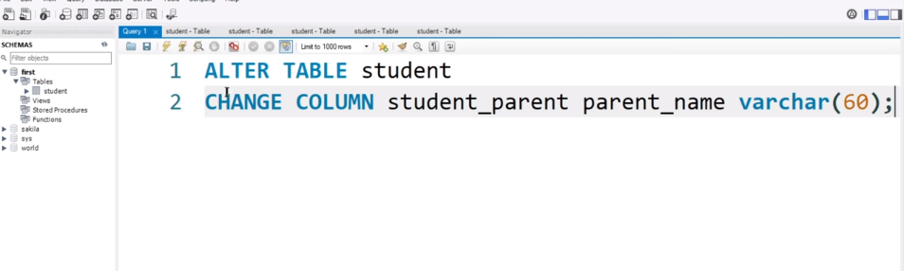

Cast =we can use change column name and datatype

Colum s delete only colum with that colum hole data will delete in atable

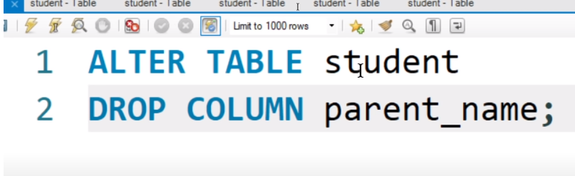

Total table delete we can use to delete table (drop) and (truncate)

* Trunkate onle data will delete table structure will threr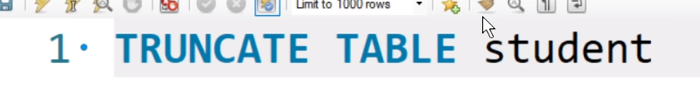
* Drop(total table will delete
* 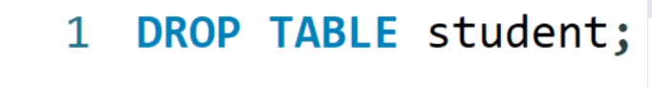

Data query language (DQL)

Only select query retrieve the data.





* Star (*)Is using for all columns will show in a result

Data manipulation language (DML)

Insert into data (only data)

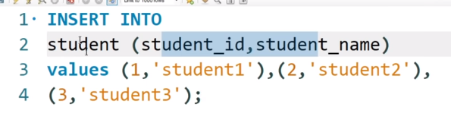

This is only two columns data adding,

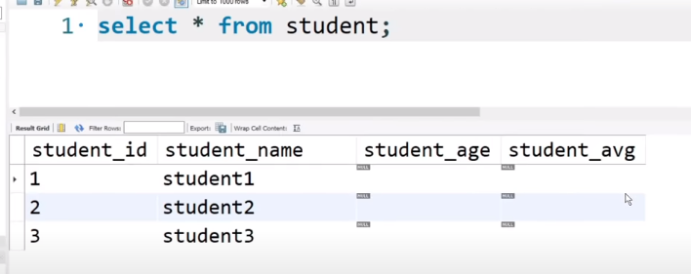

Four column data adding

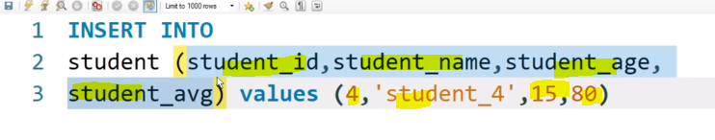

No need to mention column anmes to add the all columns data that tion leve it below iamge

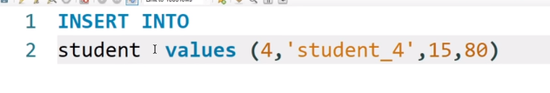

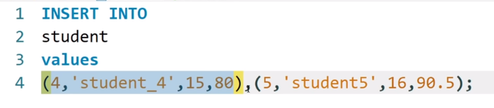

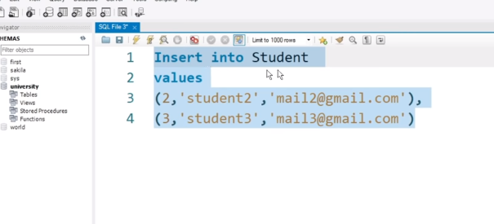

Update or change the data in table

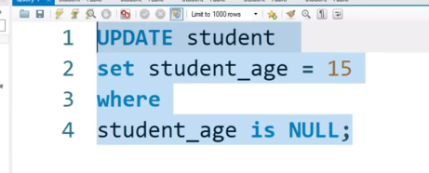

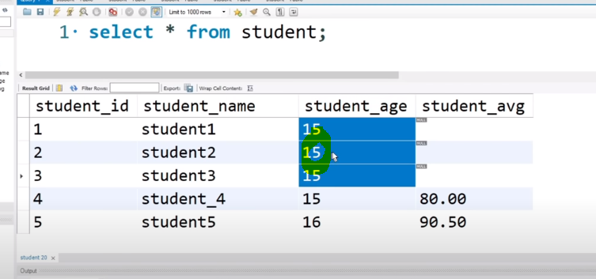

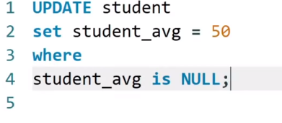

Data how to delete in table

Delete=

Need to to run before use delete query

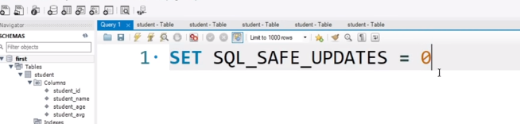

Particular rows delete

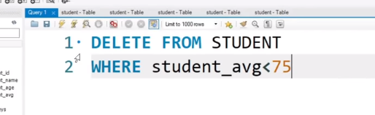

Completed table all rows will delete

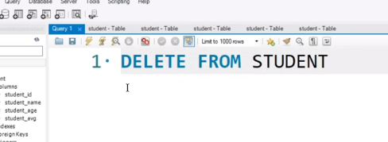

Primary key ( duplicate values and null values not there and we cant add duplicate and blanks values and null values in primary key column )

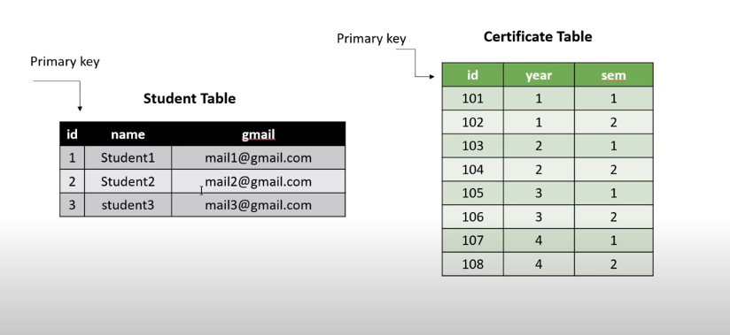

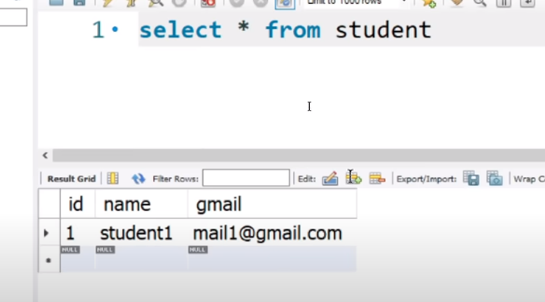

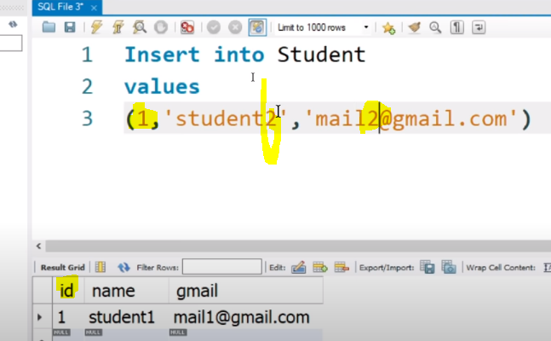

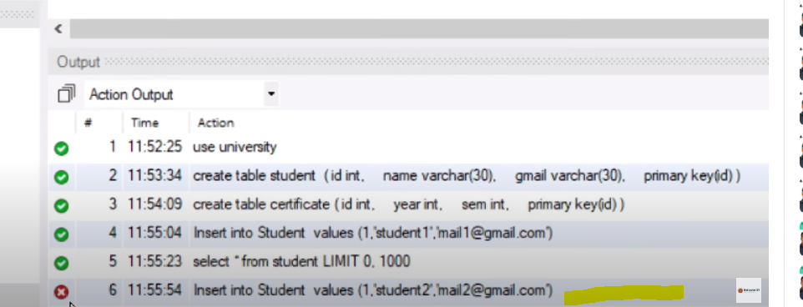

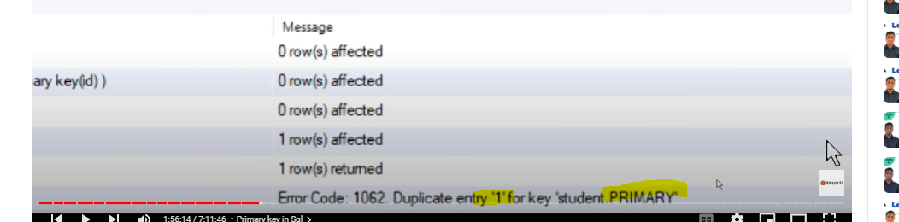

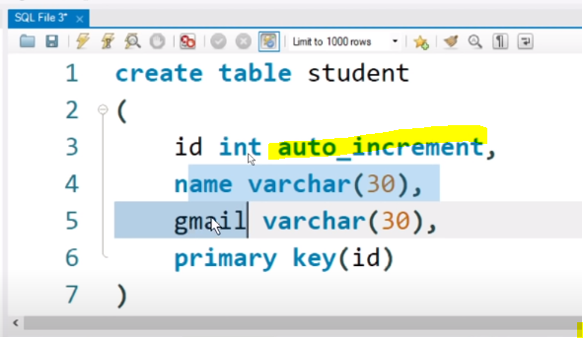

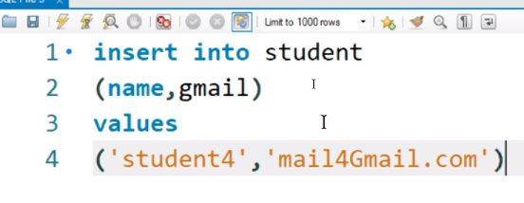

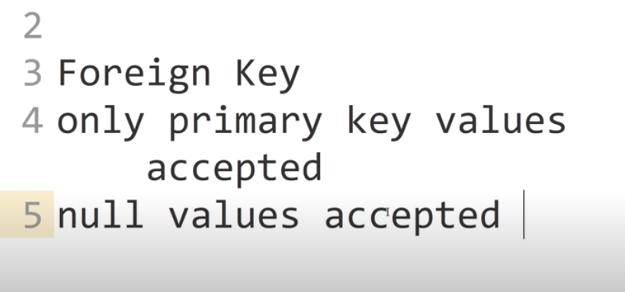

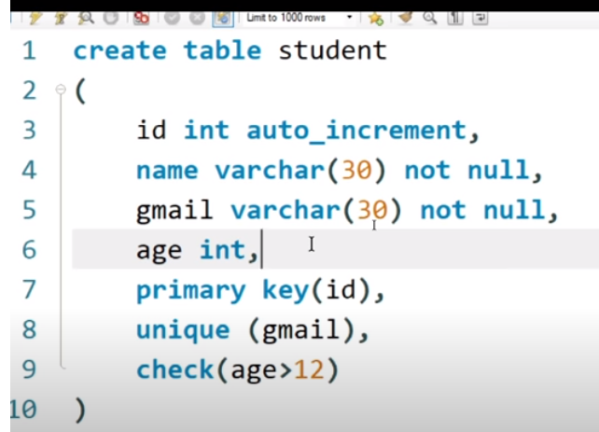

Values eichadu

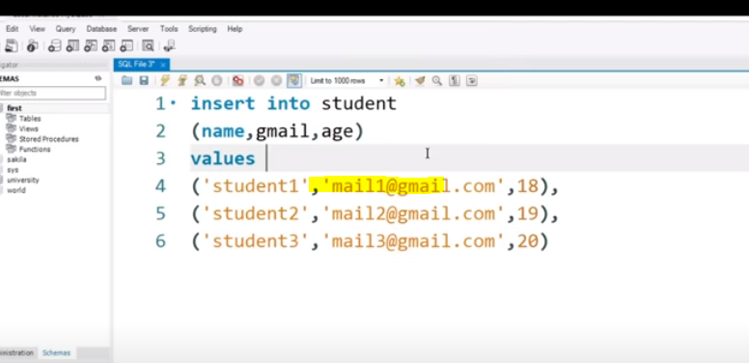

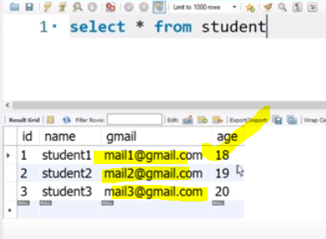

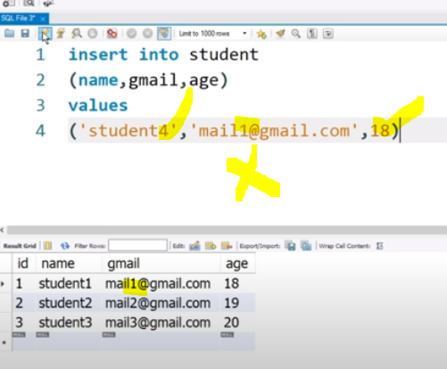

Hear email id we try to upload same id but in table creation time gmail column have unique column , so duplicates not allowed.

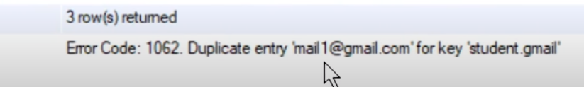

Unique

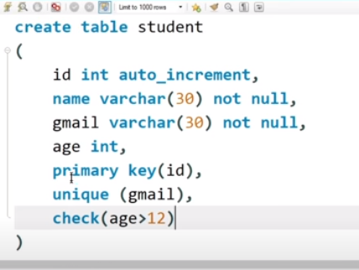

Our goal to reach

1. SQL training = <https://www.w3schools.com/sql/sql_exercises.asp>

https://www.youtube.com/watch?v=nVgLiJOI2U8&list=RDCMUCoXQDML17ann6UjNHxXYXQw&start_radio=

1. Sql 9th july complet
2. Live( test cases )8th julySaturday afternoon 2 to 4 pm
3. Resume 9th july Sunday
4. Interview 10th july Monday sey(crack kaisa carna )

Live practice Friday 7am 10.30 am